Get off me - Game plan

# Mechanics - V1.0

* Player should have the ability to grow if a good cell hits him and should shrink when a bad cell hits him. (good cell is green and bad cell is red)
* Enemies could be dragged out of the map and will lose a life if they reach the border of the map, when they lose a life, they will gain speed and return back to the map.
* Enemies will spawn infinitely near the borders of the map, this will happen at a random rate.
* Score will be kept in a score counter in the top right corner of the screen, every time an enemy gets dragged out of the map a score of +50 will be added to the score counter.

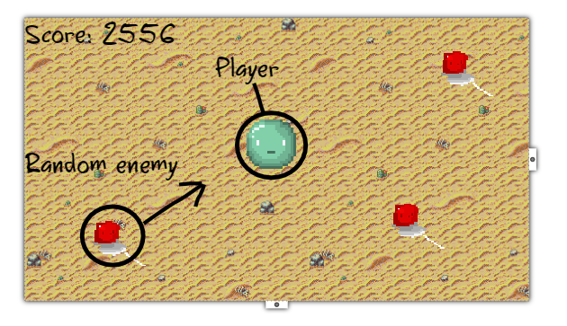

Map proposal

# UI – V1.0

### Main menu

The main menu should contain the following items:

* A play button to actually start the game.
* Button to show the highscores and the players current highscore.

### Game over menu

* Restart button
* Score counter of last game
* Players personal highscore
* Exit button to main menu